Steel Battalion Controller
on Windows 7

by Simon Postma

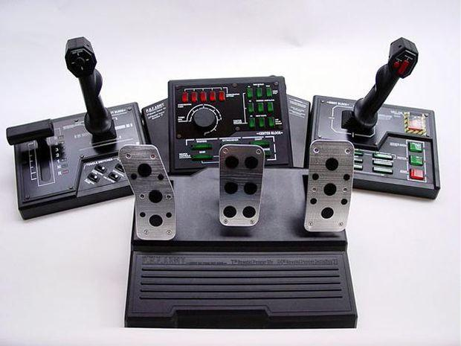

Table of Contents
Foreword 3
Overview 4
Installation & Use 6
Prerequisites 6
Drivers 6
SteelBattalion-64 6
Calibration 7
Game configuration 7
Customization, Technical Info & Development 8
Links 8
Preset SteelBattalion-64 Configuration Files 8
Creating SteelBattalion-64 Configuration Files 9
Developing software with SteelBattalion.Net 10

Foreword
This guide is a bringing together of the amazing work done by very talented and smart people, which they shared freely online for everyone to enjoy. All credit goes to them. Too bad I don’t know their names but here they are:

- SteelBattalion.Net dev
- SteelBattalion-64 Dev
- The guys that contributed to the on the SB64 wiki
- Vjoy developers

Overview
This was written as a refresher to myself and because it’s pretty difficult to figure out what’s going on online these days when it comes to using your SB controller with Windows 7. Even though most of the tools made to connect the SB controller to your computer were developed specifically for Windows 7.

Steel Battalion is a video game created by Capcom for the Xbox console where the player controls a "Vertical Tank"—a bipedal, heavily armed mecha. To control the tank and play the game requires the use of a large controller made specially for Steel Battalion. The controller has two control sticks and around 40 buttons. Only limited quantities were made available. These quickly sold out, making the game a collector's piece. It has since been re-released in limited quantities worldwide, with blue controller buttons distinguishing it from the first edition with green buttons.

There are currently two projects still available online that focus on making the SB controller work with Windows 7. They are

- Steel Battalion Net
https://github.com/jcoutch/steel-battalion-net
.NET Library for interfacing with the Steel Battalion controller (via LibUSB). The baseline driver, this does nothing but allowing your computer to communicate with the controller and make it show up in the device manager. This project was originally hosted on codeplex and google code, you can now find it on github. You need more than this to use the controller in video games.
- Steel Battalion 64
https://sourceforge.net/p/steel-battalion-64/
This package contains some slightly dated but still crucial drivers and tools that are required to let your SB controller work with Windows 7. This package contains:
  - All the necessary prerequisites that need to be installed for this to work
  - A dated version of the driver
  - vJoy (a tool for managing and using custom controllers)
  - and most important of all the SteelBattalion-64 tool that binds everything together and even lets you customize how the controller behaves (using C#, so not for beginners)

The files that come with this package are made up mostly from the above repositories. Included are:

- Documentation
  - This guide, with info on installation, usage, development, technical info and more
  - Official Steel Battalion manual
  - ‘Steel Battalion for Dummies’
  - vJoy SDK manual
- Binaries (ready to go)
  - Prerequisites
  - Drivers
  - SteelBattalion-64 (used to make controller input readable by games) with several presets
- Development files
  - Development Libraries
  - Code projects & examples
  - Copies of most available packages
- Other
  - AntiMicro (open source software used for mapping keyboard input to controllers)

Installation & Use

Prerequisites
- Navigate to the following folder and run both installers.
\SB Final\Bin\01 Prerequisites\

Drivers
- First navigate to the following folder and enable Windows Driver Testing mode with
\SB Final\Bin\02 Drivers\dseo13b.exe
- After restarting your computer, navigate back to the same folder, install vJoy using
\SB Final\Bin\02 Drivers\vJoySetup2166.exe
- Now connect the Steel Battalion controller to your computer with the USB cable. Windows update will look for drivers first, if you can, cancel this, if not simply wait until it says it can not find the drivers.
- Then click the start button in your taskbar, type “device manager” in the search bar, and open it.
- Look for the unknown device in the list, right click it, and click “update driver software”.
- In the wizard, select the option for using local driver files. Then point it to the following folder
\SB Final\Bin\02 Drivers\SB Drivers\
- And let it install. Afterwards you should be able to see the newly installed device display its proper name: Steel Battalion.

SteelBattalion-64
What this does is reading controller input and translating it to game-ready information by using vJoy the driver we just installed. The controller will not work without using this tool.
- Navigate to the following folder and open the program
\SB Final\Bin\03 SteelBattalion-64\Steel_Batallion_64_v2.exe
- Once the program is open, click file > open and open the following file
\SB Final\Bin\03 SteelBattalion-64\Conf_SteelBatallionController.cs
- Click Start. You should see all the controller lights flash a couple of times. If you do, that means it works.

Calibration
Now that the SteelBattalion controller is behaving like an actual controller, regardless of the hackjob software involved, it is important to calibrate the input.
- Click the windows menu key on your taskbar, enter “controller” in the search field, then click on “Set up USB game controllers”.
- Click the ‘Test’ tab and push a few buttons, pull the levers and push down the pedals. If you see things light up and the bars move, that means the setup is working so far.
- Click the “settings” tab and click Calibrate. Follow the calibration wizard.
Page 1: Right aiming lever center point
Page 2 (X/Y Axis): Right aiming lever
Page 3: Left rotation lever center point
Page 4 (Z Axis): Right pedal (+) and middle pedal (-)
Page 5 (X Rotation): Sight change vertical
Page 6 (Y Rotation): Left pedal
Page 7 (Z Rotation): Left rotation lever
Page 8 (Slider): Sight change horizontal
Page 9 (Dial): Gear Lever

Game configuration
If all went well you have now reached the point where the controller is ready to play games with the Steel Battalion controller. Configuring the game to properly respond to the controller can be a bit of a task, but on average it takes me 20 minutes per game to set up the bindings and tweak the analog controls properly (basing this off my experience with ArmA 3, X: Rebirth, Eve Online and some other games).
Some things to keep in mind when it comes to configuring the game:
- Not every game has the required controller support, a shining example of this is No Man’s Sky. Being able to play NMS with the Steel Batallion controller would hage given it some redeeming quality, but alas. Expect this to happen with more games.
- You can make the most of your experience by really spending some sweet time on the sensitivity and dead zone settings, if the game you’re playing offers them. Doing so helped me turn my ArmA 3 tank driving and helicopter piloting experiences from an unplayable mess to a very enjoyable smooth ride.
- You can have far reaching influence over the way your controller and game interact with one another through modifying the configuration file used by Steel_Batallion_64_v2.exe. Doing this involves some basic programming in C#. More information about how to do this can be found in the next chapter.

Customization, Technical Info & Development

Links
Steel Battalion 64 Wiki
- https://sourceforge.net/p/steel-batallion-64/wiki/
Steel Battalion 64 Source code
- https://sourceforge.net/p/steel-batallion-64/code/
Steel Battalion controller and win 7 64-Bit drivers
- https://mwomercs.com/forums/topic/7801-steel-battalion-controller-and...

Preset SteelBattalion-64 Configuration Files
conf_SteelBatallionController.cs | A general purpose configuration file with high refresh rate and all buttons activated.
conf_MechWarriorOnline-mouse.cs | A configuration file for MechWarrior Online
conf_MechWarriorOnline.cs | A configuration file for MechWarrior Online
conf_Simple.cs | A general purpose configuration file with normal refresh rate and 8 buttons and some key mappings activated.
conf_SolExodus.cs | A configuration file for Sol Exodus
conf_MechWarrior4.cs | A configuration file for MechWarrior 4
conf_TunerDialExample.cs | Code example for using the Tuner Dial

Creating SteelBattalion-64 Configuration Files

Developing software with SteelBattalion.Net

